About Aminta Nadelman – Mini Biography
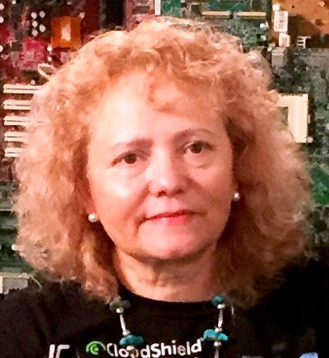

Aminta was born in Mexico City. She studied Dentistry at the University National in Mexico City and later moved to the United States and Married Michael Nadelman. Aminta and Michael have three children and began her studies in South San Francisco and later at Skyline College in Pacifica. Her major studies included Psychology and English as a Second Language. Aminta Then went to school in San Leandro and began her studies in The Montessori Method as a teacher.
Aminta worked six years at Montessori of Linda Mar, in Pacifica, California and then for two years in Mexico City at a Montessori School called Escuela Juan Escutia where she taught the Montessori Method to underprivileged children.
Currently Aminta work at Bright Angel Montessori School in Menlo Park California.
Aminta enjoys art, dancing, reading and theatre.

